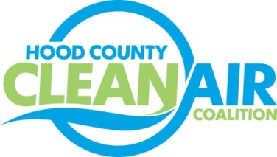
Meeting: Thursday, March 1, 2018
Neely House
304 East Rucker Street, Granbury, Texas 76048
8:30-10:00 a.m.

Agenda

- Call Meeting to Order
- EPA Updates – Randy Pitre, EPA
- Local Updates – Michelle McKenzie
  - Review of February Meeting Summary
  - Review of Projects
    - Monthly Budget Review for January
    - Status of Projects FY 16/17/18
  - Alternative Funding Status
  - Annual Officer Elections in April
- Regional Updates – Michelle McKenzie
  - Air North Texas Campus Clean Air Action Days
  - Upcoming DFW Clean Cities Events:
    - CNG Fuel System Technician Training – March 21, Momentum Fuel Technologies 8:30-4:00 pm
    - Meeting: Sustainable Landscaping in DFW – March 27, Plano Environmental Education Center 1:30-3:00 pm
  - Funding Opportunities, www.nctcog.org/aqfunding
    - TERP Alternative Fueling Facilities Program
    - TCEQ Clean School Bus Program – Now Offering Replacement of Diesel School Buses
    - Tesla Charging Incentive
    - TCEQ New Technology Implementation Grant
  - TCEQ Accepting Comments on How Volkswagen Funds Should be Used in Texas - https://www.tceq.texas.gov/agency/trust
- Other Discussion
- Adjourn

